iView 3.5 Handheld Video Magnifier ESVM0090
Product Instructions
General description
Anyview® iView 3.5 inch handheld video magnifier is of exquisite, frivolous and portable structure design. It is easy to put in the pocket to view whenever and wherever it is needed. With advanced technology of auto-focus and clear image, it marks the breakthrough of solving the blur, shadow and vertigo. The foldable writing stand makes the writing easy and convenient. 8 contrast modes are available for users. Compared with other 3.5 inch items, its exquisite and frivolous body brings convenience, clearance, stability, and brilliant vision enjoyment.

1. Parts & Accessories
Video Magnifier
Short Strap
User manual
Video cable
Protective case
AC power Adapter
USB Cable

2. Structure
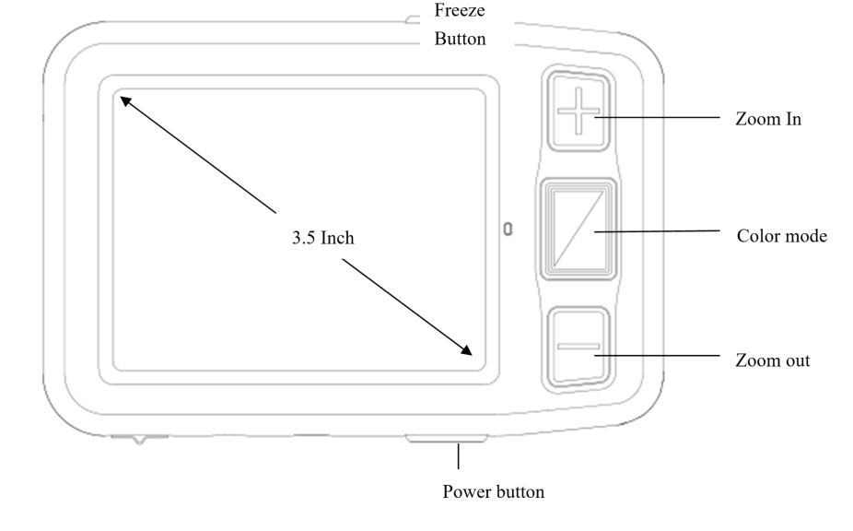
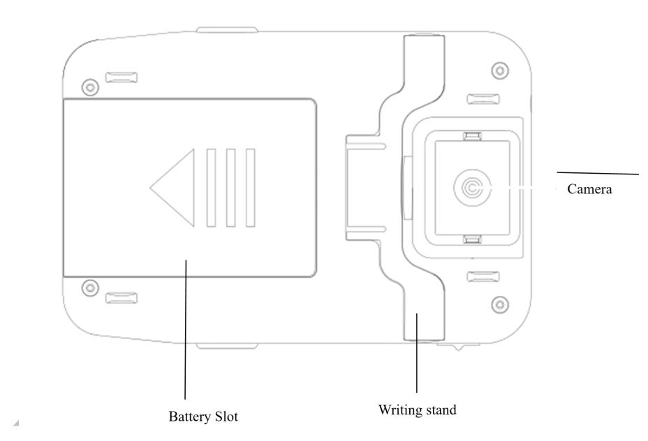
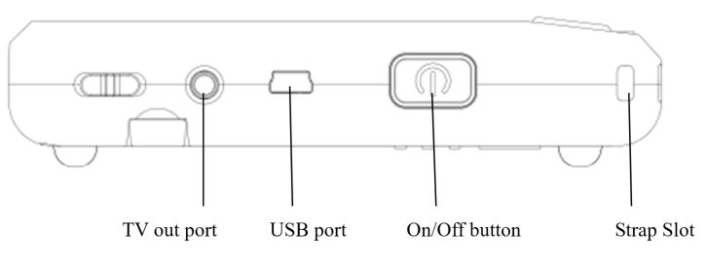

3. Using guide
3.1 Installation of short strap
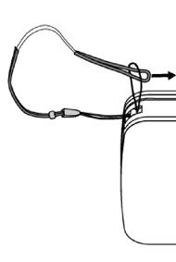
3.2 Functions Operation Instruction
Press and hold the power button for 3 seconds unit the BEEP heart to turn on, the screen will show the opening image for 2 seconds and then the unit will enter into video magnifier mode
Press and hold the power button for 2 seconds to turn off.
3.2.2 Zoom In/Zoom Out
Press the “+” button to zoom in, and press the “-”button to zoom out，you can choose the right and preferred magnification.
3.2.3 Contrast color mode and Camera lighting function
- Normal mode and favorite mode are available for contrast color mode.
- Press and hold the contrast mode button for 2 seconds can switch between the normal mode and favorite model
- In favorite mode, press the mode button to cycle through 3 basic modes: full color, your favorite contrast color and the reverse (such as white on blue & blue on white)
- In Normal mode, press the mode button to cycle through the following 8 color modes:
- Full color mode
- Grey mode
- High contrast white text on black background
- High contrast black text on white background
- High contrast yellow text on black background
- High contrast black text on yellow background
- High contrast blue text on yellow background
- High contrast yellow text on blue background
- Press and hold the contrast color mode for 5 seconds to turn on/off the camera lights.

3.2.4 Brightness Adjustment
- Hold the “Freeze” button and “Zoom in”button together to to enter into brightness adjustment.
- A brightness bar shows, then press “Zoom in” to increase brightness and “Zoom out” to decrease it.

3.2.5 Freeze Function
- Use Freeze button to capture images and letters, Take the unit closer to have a carefully look at the object, and you can also magnify or minify images by +/- button and switch contrast modes by Mode button
- Press the Freeze button again to release

3.2.6 Setting memory function
- The unit will memorize automatically the most recent settings (e.g. color mode, magnification, video output format, button beeps, brightness) and use them in the next power on.
3.2.7 Power saving function
- Under magnification mode, the unit will turn off automatically if no operation for over 3 minutes.
3.2.8 TV output function
- If the unit screen size is not enough for you, then you can use the TV output function to connect to the TV screen for magnification.
- After the TV output connected to TV, turn on the unit, the image will automatically switch on the TV screen.

4. Troubleshooting

Black screen
- To check if it is on or off
- To check if the camera is covered by dirty spot.
- Decrease the magnification.

Unable to turn on
- To check if the battery is in or if the battery has the power.
- Try to use the power adapter to turn on.

Image darkness and twist on the screen
- To check if the reading material is laid flat
- To check if the camera lights are off.

No display after connected to TV
- To check if the TV is on
- To check if the wire is correctly TV output and connected to TV
- To check if it is the correct TV output mode

Unable to recharge
- To check if the power adapter is connected well.

5. Safety Guide
To keep the video magnifier in good conditions, please read the following safety guide carefully:
- Do not expose iView 3.5 to excessive heat or direct sunlight to avoid the risk of fire.
- Do keep away from the humidity, rain, liquid and chemicals.
- Do not use this magnifier near inadequately shielded medical devices.
- Do use this magnifier under the temperature between 10°C and 40°C
- Do not try to repair the magnifier by yourself or open the its shell as it will void the warranty. Contact your dealer to service this equipment if necessary
- Always unplug the system before cleaning. Use a soft damp cloth to clean the exterior. Do not use cleaning agents or abrasive materials as they will damage your unit.
- Do use its matched adapter to recharge, otherwise it will damage the unit.

6. Technical Specifications
- 3.5-inch TFT LCD screen
- 2x -16x continuous zoom
- Focus: Auto focus
- TV Out: PAL/NTSC
- Power saving mode: the unit will turn off automatically after inactivity for 3 minutes
- Writing stand
- Fast reading with no blur
- Charging time: About 3.5 hours
- Functions: Freeze image, Switch color mode, Zoom in/out
- Settings saved after power-off
- Lighting function
- Battery level indicator：Positive
- Lightweight design at 150 g.
- 8 high-contrast colour viewing modes(3 favorite color modes)
- Battery: rechargeable lithium battery 4 hours continuous use
- Accessories: user manual, AC power adapter, short strap, protective case, video output cable
- Operation and storage conditions: Humidity<70% Temperature:10-40℃

