Vision Australia

ORBIT Reader 20 Getting Started

Draft V1, FW V1.00.56

Orientation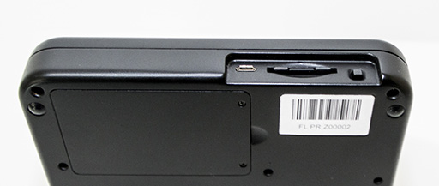
The Power button, SD card slot, and Micro USB port are on the rear. The battery compartment is located on the bottom of the device.
Key Placement and Use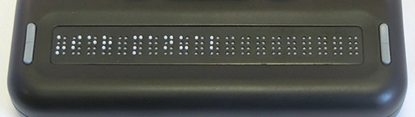
Place the Orbit Reader so that the braille cells are closest to you. The Panning keys are at each end of the braille display. These keys control how you read lines of text.
The wide centre key is the Space bar. The dot 7 input key is to the left and the dot 8 input key is to the right.
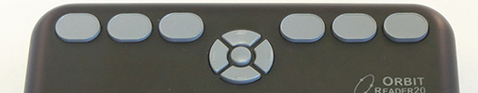
There is a navigation pad in the top centre. These are four ‘arrow’ buttons (Up, Down, Left, Right) and the middle Select button.
The six traditional braille input keys are on each side of this, and dot 7 and 8 are on each side of the space bar.
In Stand Alone mode, the braille input keys act as navigation controls (e.g. dots 3 and 6 serve as Page Up and Page Down to move through a title).
When using the display with a screen reader such as a computer or iPhone, the Braille input keys can be used to input text or control functionality of applications on the device.

Supported File Types
Braille files may contain any kind of braille. You create these files on a computer with a translation software package such as Duxbury, or you can create them in the Editor on the Orbit Reader.
Ext | Type | Explanation
BRF | Translated, formatted braille | displays exact representation
BRL | Translated, unformatted braille | displays all text
TXT | Text | displays eight-dot Computer Braille

Orbit Reader will show the contents of any file. However, Orbit Reader does not translate and there is no guarantee that unsupported file types are readable.
In addition to reading braille, Orbit Reader offers the ability to write and edit text.

Getting Started
The Orbit Reader 20 has two modes: Stand Alone mode and Remote mode.
Stand Alone mode is the default mode. It allows you to read, edit, and browse files without being connected to another device. A formatted SD card must be used.
In Remote mode, the Orbit Reader provides braille input and output to a computer, phone or tablet.

Charging the device
Fully charge the unit before or during first use.
To charge the device, use a standard micro USB cable. Insert the cable into the Orbit Reader's USB port with the ‘bumps’ facing down.
If the device is on when you connect the power, the display shows "Charger connected". When you unplug the charger, it shows "Charger unplugged". This is briefly displayed even when the unit is off.

Powering On and Off
The Power button is in a recessed area on the back of the device.
To turn on, Press and hold the Power button for 2 seconds. Orbit Reader flashes the first braille cell to let you know it is turning on.
To turn off the device, press and hold the Power button for 2 seconds.
When turned on, Orbit Reader resumes from the last reading position. If this is the first time you are using the device, Orbit Reader shows the first file or folder name on the SD card.
If no keys are pressed for 10 minutes and the device is running on batteries, the unit automatically powers off to conserve power.
The battery takes 3 hours to charge, and lasts for 3 days of normal use.
Inserting an SD Card
The SD card is inserted with the contacts facing down.
Insert the SD card in the slot on the back next to the power button.
Gently push the SD card in until you hear a click. The card is flush with the rear edge when properly inserted.
To remove the card, power off the Orbit Reader, then press and release the card until it ejects.

Reading Braille
When first powered on, the Orbit Reader displays the contents of the first file on the SD card.
You may start reading immediately by using the Panning keys on either side of the braille display.
To… | Do this
Scroll and go to Previous or Next text | use the Panning buttons
Go to Previous or Next Page | press dot 3 or dot 6
Find Braille | press Space + F (dots 1 2 4)
Exit File or Menu | press dot 7 (button on left of space bar)

Press dot 7 to display the File Manager, which shows a list of the files on the SD card. Press Select or dot 8 to open a file or folder.
To find a file, use the Up or Down arrows or type the first few letters of the file's name. The first file matching the letters you typed is displayed.
Press dot 7 at any time to exit or go back.
Once a file is selected (Up or Down Arrow + Select), the file opens.
When moving through menus or managing and reading files, the Orbit Reader shows the first 20 characters.
See the User Guide for a detailed list of key commands for reading, editing and managing files.

Entering and Exiting Menus
The navigation pad has four ‘arrow’ buttons (Up, Down, Left, Right) and the middle Select button. Use the navigation pad to open the menu for setting options, checking battery, and changing modes of operation.

To… | Do this
open the menu | press Select (middle button) + Up
Exit File or Menu | press dot 7 (button on left of space bar)
move through the menu choices | press the Up or Down
see choices within a menu option | use the Right and Left
select a menu item | press Select (middle button)

Remote Mode
The Orbit Reader connects with computers, phones, and tablets to provide braille input and output to that device. The host device must be running software that supports braille.
- For Windows PCs - JAWS®, Window-Eyes, System Access, and NVDA
- For Mac® computers and iOS® devices - VoiceOver
- For Android devices - BrailleBack and TalkBack
The screen reader provides the translation and other braille settings.
Consult the documentation for the screen reader for details about connection and commands to use for that screen reader.
- Pressing Select + Up Arrow opens the Orbit Reader Menus.
- Pressing Select + Left Arrow returns Orbit Reader to Stand Alone mode.
- Pressing Select + Right Arrow returns Orbit Reader to Remote mode.
- Pressing Select + Down Arrow brings up an Edit box where you can type and submit up to 255 characters of text to the remote device.
- Press dot 8 to send the text and exit the Edit Box.
By default, the device is identified as "Orbit Reader 20" to the screen reader applications. This can be changed in the Emulation Mode menu item on the Orbit Reader.
By default, when the user turns on the device, it is ready to pair or to connect via Bluetooth. You may turn off Bluetooth in the menu to conserve battery power.
Connecting the device via USB charges the battery and provides a file transfer mechanism.
By default, the Orbit Reader chooses Bluetooth as the preferred connection when both USB and Bluetooth are present.

Connecting to a PC or Mobile Device
See the User Guide for a detailed list of commands and instructions.
Below is the method for connecting to an iOS device such as an iPhone.
iOS Devices (Version 10.0 or later)¶
Connecting Orbit Reader to an iOS device provides both braille feedback and the ability to control the device.
By default, the Orbit Reader is ready to pair with iOS with Bluetooth.
On the iOS device go to:
Settings>General>Accessibility>VoiceOver>Braille and look for the name of the unit in the list of possible braille displays. It shows up as Orbit Reader plus the last four digits of the serial number.
Activate the Orbit Reader 20 device in the list to initiate pairing.
Once you pair the unit, iOS will start sending braille to the Orbit Reader, and you can use the Orbit Reader input and navigation keys to control your iOS device.
For more information about iOS and braille displays, see Braille Displays for iOS on the Apple® Accessibility website.

Key Lock Command
This prevents accidental key presses. Hold dots 7 8 for two seconds or more. Pressing and holding these same keys again unlocks the keys.

System Alerts
System alerts, such as "Battery low" are indicated by a periodic cycling of the eight dots in the last cell of the device.

Reboot the Device
In the event the Orbit Reader locks up, the unit can be rebooted by pressing the lower Right Panning key + dot 8. There is no indication of the reset event. The unit is in power off condition after reset and needs to be powered on before it can be used.

END

