Pangoo 5.5 HD handheld video Magnifier ESVM0091
Product Instructions
General description
Anyview® Pangoo 5.5 HD handheld video magnifier is of integrated design for close view and distance view with high resolution. The 5.5 inch LED HD screen brings magnificent viewing experience, while HDMI output offer the option of wider screen vision. The working distance from 3.96cm to 600cm satisfies the end user’s close view and distance view requirements. The special 2 HD cameras mean excellent viewing conformity. With excellent functions and special color technology, this magnifier brings you outstanding vision enjoyment.
1. Parts and Accessories
- Video Magnifier
- Short Strap
- User Manual
- HDMI
- Protective case
- AC Power Adapter
2. Structure
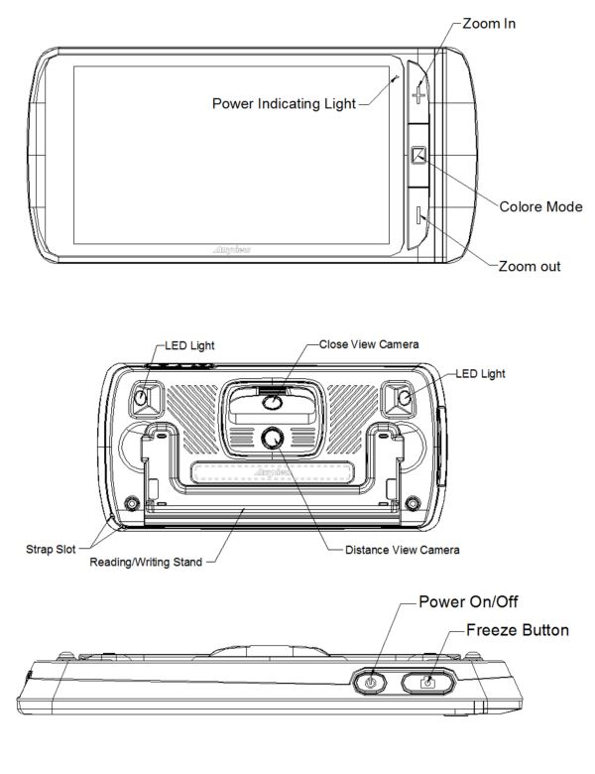
3. Using Guide
3.1 Power on/off function
- Press and hold the power button for 3 seconds unit the BEEP heart to turn on, the screen will show the opening image for 2 seconds and then the unit will enter into video magnifier mode
- Press and hold the power button for 2 seconds to turn off.
Notice: the unit automatically turn off in case of power lack.
3.1.1 Two camera switch
- For reading, choose close view mode.
- For far sight, choose distance view mode.
- Close/Open the writing stand to switch between close view and distance view. Under the distance view mode, the unit shows this icon 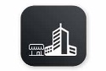, in case of close view model, it shows this icon
3.1.2 Assistive camera lights
- Long press the color model button for 5 seconds unit the beep sound, turn on or off the assistive camera lights
- In case of close view model, the unit automatically turn on the lights, while in distance view model, the unit measure the distance, turn on or off the lights according to the lighting conditions.
3.1.3 Auto-focus function
The auto focus is available for close and distance view mode.
3.1.4 Contrast color mode
- Normal mode and favorite mode are available for contrast color mode.
- Press and hold the contrast mode button for 2 seconds can switch between the normal mode and favorite mode.
- In favorite mode, press the mode button to cycle through 3 basic modes: full color, your favorite contrast color and the reverse (such as white on blue & blue on white)
- In Normal mode, press the mode button to cycle through the following 10 color modes:
- Full color mode
- Grey mode
- High contrast white text on black background
- High contrast black text on white background
- High contrast white text on blue background
- High contrast blue text on white background
- High contrast yellow text on black background
- High contrast black text on yellow background
- High contrast blue text on yellow background
- High contrast yellow text on blue background
- High contrast green text on black background

3.1.5 Zoom In/Zoom Out
- Press the “+” button to zoom in, and press the “-”button to zoom out, you can choose the right and preferred magnification.

3.1.6 Brightness Adjustment
- Hold the “Freeze” button and “Zoom out” buttons together to enter into brightness adjustment.
- A brightness bar shows, then press “Zoom in” to increase brightness and “Zoom out” to decrease it.

3.1.7 Touch Screen Function
(1)Freeze function
- Use Freeze button to capture images and letters until beep sound. Take the unit closer to have a carefully look at the object, and you can also magnify or minify images by +/- button and switch contrast modes by color Mode button
- Under the frozen mode, press the Freeze button again, the unit will indicate to save the picture or not. Choose No(cross) back to view mode; Choose(tick) to show a indication, save picture. Saving up to 20 pictures.
(2) Album reading function
- Long press the freeze button for 3 seconds, the unit vibrate and enter the album.
- The screen shows direction icons, left/right direction icons means to switch the pictures, down direction means to delete the picture.
- Click the album picture, zoom in and zoom out functions are available, and can scroll the picture.
- Click the left upside icon to come back the album menu.
- Long press the freeze button for 3 seconds, the unit vibrate and exit the album and back to view mode.

3.1.8 HDMI output
If the unit screen size is not enough for you, then you can use the HDMI output function to connect to the TV screen for magnification.

3.1.9. The Hz adjustment
- Under the view mode, long press the zoom in button for 5 seconds until the unit show icon. It can switch between 50hz and 60hz.

3.1.10 Working time
- Working time is more than 4 hours.

3.1.11 Power saving function
- Under magnification mode, the unit will turn off automatically if no operation for over 3 minutes.

3.1.12 Setting memory function
- The unit will memorize automatically the most recent settings (e.g. color mode, magnification, video output format, button beeps, brightness) and use them in the next power on.

3.1.13 Factory mode setting
- Long press the zoom out button for 5 seconds to set the factory mode.

3.1.14 Power charging
- Unit on, indicate the power level
- Unit off for charging, the red light on, once power full, the red light off.
- Unit on for charging, the orange light on, once power full, the orange light off.

4. Trouble Shooting
Black Screen
- to check if it is on or off.
- To check if the camera is covered by dirty spot.
- Decrease the magnification.

Unable to turn on
- To check if the battery is in or if the battery has the power.
- Try to use the power adapter to turn on.
- Press the power button together with color mode button for 3 seconds to turn on.

Image darkness and twist on the screen
- To check if the reading material is laid flat.
- To check if the camera lights are off.

No display after connected to TV
- To check if the TV is on.
- To check if the wire is correctly TV output and connected to TV.
- To check if it is the correct TV output mode.

Unable to recharge
- To check if the power adapter is connected well.

Image blurring
- Long press the Freeze button for 6 seconds to make autofocus.

5. Safety Guide
To keep the video magnifier in good conditions, please read the following safety guide carefully:
- Do not expose IView5 HD to excessive heat or direct sunlight to avoid the risk of fire.
- Do keep away from the humidity, rain, liquid and chemicals.
- Do not use this magnifier near inadequately shielded medical devices.
- Do use this magnifier under the temperature between 10°C and 40°C
- Do not try to repair the magnifier by yourself or open the its shell as it will void the warranty. Contact your dealer to service this equipment if necessary
- Always unplug the system before cleaning. Use a soft damp cloth to clean the exterior. Do not use cleaning agents or abrasive materials as they will damage your unit.
- Do use its matched adapter to recharge, otherwise it will damage the unit.

6. Technical Specifications
- 5.5-inch full color LED scree
- 2x -23x continuous zoom
- Continuous magnification: Select the suitable magnification
- Camera: 720p HD
- Colore mode: total 15 color modes
- Focus: Auto focus
- Working distance: 3.96-600cm
- Battery: rechargeable lithium battery 4 hours continuous use
- Power saving mode: the unit will turn off automatically after inactivity for 3 minutes
- Fast reading with no blur
- Charging time: About 5 hours
- Functions: Freeze image, Switch color mode, Zoom in/out
- Settings saved after power-off
- HDMI output
- Battery level indicator：Positive
- Power supply: Input:110-240V, Output: 5V, 2.5A
- Size: 80x180x18mm

