iView 7 Handheld Video Magnifier ESVM0092
Product Instructions
General description
A high-definition portable electronic magnifier with a large 7-inch anti-glare screen and 5 Mega Pixels camera. Provides excellent picture quality for viewing text and images. It features a rotatable camera that can be used to change between the distance view and close view functions. It can also connect to a TV or monitor.

1. Parts & Accessories
Video Magnifier
User manual
HDMI cable
Protective case
AC power Adapter

2. Structure 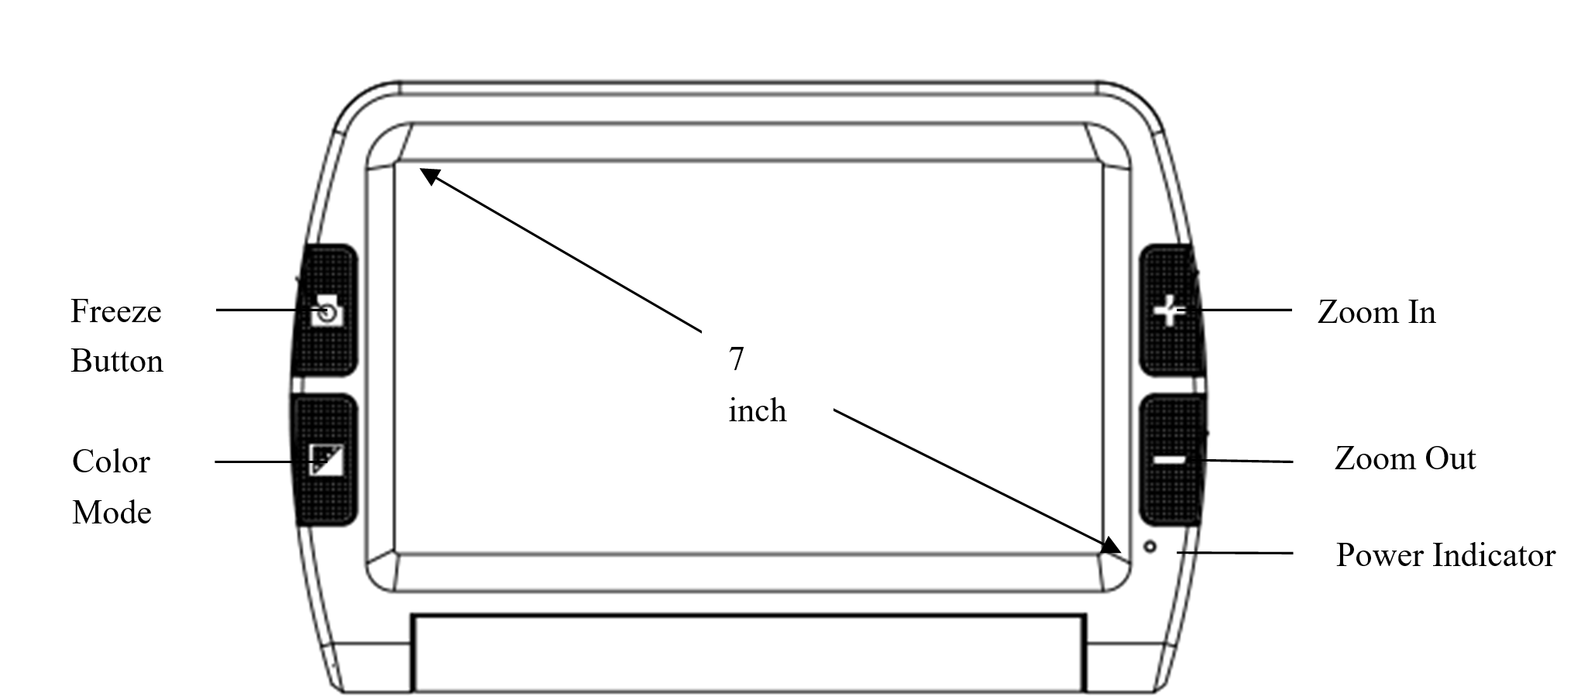

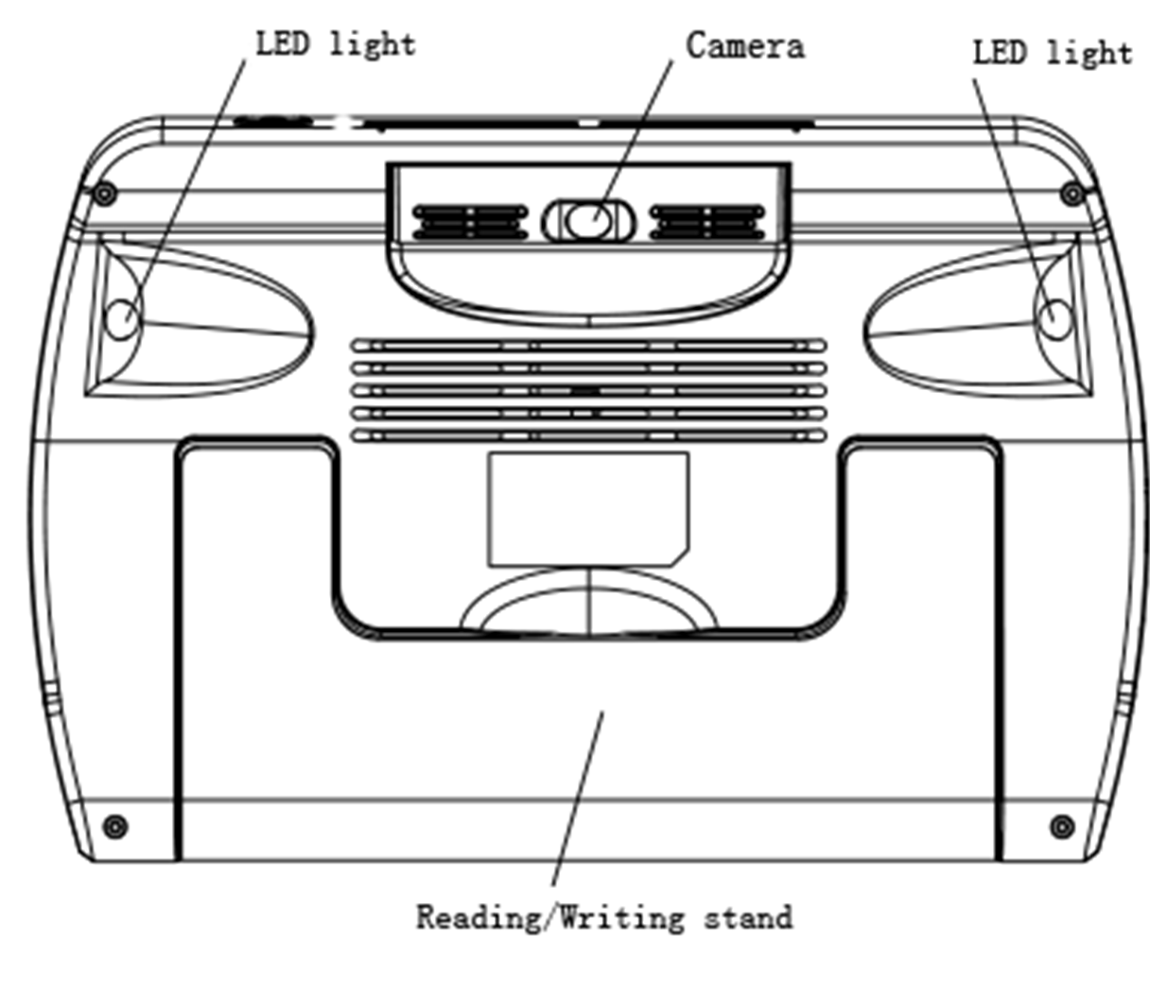
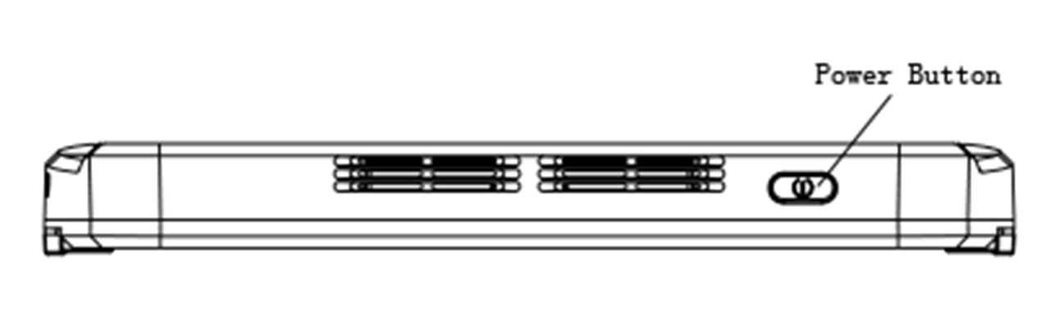

3. Using guide
3.1 Functions operation
3.1.1 Power on/off
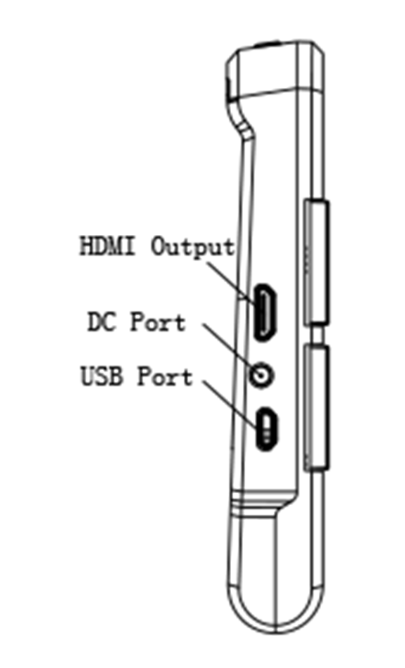

Press and hold the power button for 3 seconds unit the BEEP heart to turn on, the screen will show the opening image for 2 seconds and then the unit will enter into video magnifier mode
Press and hold the power button for 2 seconds to turn off.
3.1.2 Zoom In/Zoom Out
Press the “+” button to zoom in, and press the “-”button to zoom out，you can choose the right and preferred magnification.
3.1.3 Contrast color mode and Camera lighting function
- Normal mode and favorite mode are available for contrast color mode.
- Press and hold the contrast mode button for 2 seconds can switch between the normal mode and favorite model
- In favorite mode, press the mode button to cycle through 3 basic modes: full color, your favorite contrast color and the reverse (such as white on blue & blue on white)
- In Normal mode, press the mode button to cycle through the following 8 color modes:
- Full color mode
- Grey mode
- White text on black background mode
- Black text on white background mode
- White text on blue background mode
- Blue text on white background mode
- Yellow text on black background mode
- Black text on yellow background mode
- Blue text on yellow background mode
- Yellow text on blue background mode
- Green text on black background mode
- Black text on green background mode
- Press and hold the contrast color mode for 5 seconds to turn on/off the camera lights.

3.1.4 Brightness Adjustment
- Hold the “Freeze” button and “Zoom in”button together to to enter into brightness adjustment.
- A brightness bar shows, then press “Zoom in” to increase brightness and “Zoom out” to decrease it.

3.1.5 Freeze Function
- Use Freeze button to capture images and letters, Take the unit closer to have a carefully look at the object, and you can also magnify or minify images by +/- button and switch contrast modes by Mode button
- Press the Freeze button again to release

3.1.6 Setting memory function
- The unit will memorize automatically the most recent settings (e.g. color mode, magnification, video output format, button beeps, brightness) and use them in the next power on.

3.1.7 Power saving function
- Under magnification mode, the unit will turn off automatically if no operation for over 3 minutes.

3.1.8 TV output function
- If the unit screen size is not enough for you, then you can use the HDMI output function to connect to the TV screen for magnification.
- After the HDMI output connected to TV, turn on the unit, the image will automatically switch on the TV screen.

3.1.9 Distance View/Close View function
- When you read paper materials such as books, you can choose close view mode
- When you want to see the objects in certain distance, you can choose distance view mode.
- To switch between the distance view and close view mode, you just only need to rotate the camera simply.

4. Troubleshooting

Black screen
- To check if it is on or off
- To check if the camera is covered by dirty spot.
- Decrease the magnification.

Unable to turn on
- To check if the battery is in or if the battery has the power.
- Try to use the power adapter to turn on.
- Press the power button together with colour mode button for 3 seconds to turn on.

Image darkness and twist on the screen
- To check if the reading material is laid flat
- To check if the camera lights are off.

No display after connected to TV
- To check if the TV is on
- To check if the wire is correctly TV output and connected to TV
- To check if it is the correct HDMI output mode

Unable to recharge
- To check if the power adapter is connected well.

Image blur
- Press and hold the Freeze button for 6 seconds to set the auto focus.

5. Safety Guide
To keep the video magnifier in good conditions, please read the following safety guide carefully:
- Do not expose iView7 HD to excessive heat or direct sunlight to avoid the risk of fire.
- Do keep away from the humidity, rain, liquid and chemicals.
- Do not use this magnifier near inadequately shielded medical devices.
- Do use this magnifier under the temperature between 10°C and 40°C
- Do not try to repair the magnifier by yourself or open the its shell as it will void the warranty. Contact your dealer to service this equipment if necessary
- Always unplug the system before cleaning. Use a soft damp cloth to clean the exterior. Do not use cleaning agents or abrasive materials as they will damage your unit
- Do use its matched adapter to recharge, otherwise it will damage the unit.

6. Technical Specifications
- Magnification: 2.3X ~ 19X
- High contrast color modes: 12 modes (3 favorite color modes)
- Screen: 7-inch ISP LCD screen
- Camera: Auto focus: 5M pixels
- Continuous magnification: Select the suitable magnification
- Viewing distance: 6.8cm ~ 600cm (2.68~ 236.22“)
- Functions: Freeze image, Switch color mode, Zoom in/out
- Settings saved after power-off
- Power-Saving: IView7 HD turns off automatically if non-use in 3 minutes
- Connect to HDMI/Monitor
- Power adapter: Input: 110—240V
- Continuous use: 5 hours maximum
- Charging time: 4~5 hours
- Total weight: < 440g
- Dimension: 195mm*139.5mm*25mm

