ClearView ESVM2006

Product Instructions

General description
This 22" desktop video magnifier offers brilliant image quality in a stylish, modern design. Provides adjustable magnification up to 27 times. The unique C-shape allows a larger reading area and flexibility for completing crosswords or crafts.

What is included
The ClearView C packaging contains the following:
    - The ClearView C
    - A power cord
    - The wireless Control Pad
    - The Instruction Sheet for the wireless Control Pad
    - This user manual
    - The Instruction Sheet for switching the table setup

Getting to know your ClearView C
The following figures show the ClearView C’s main components.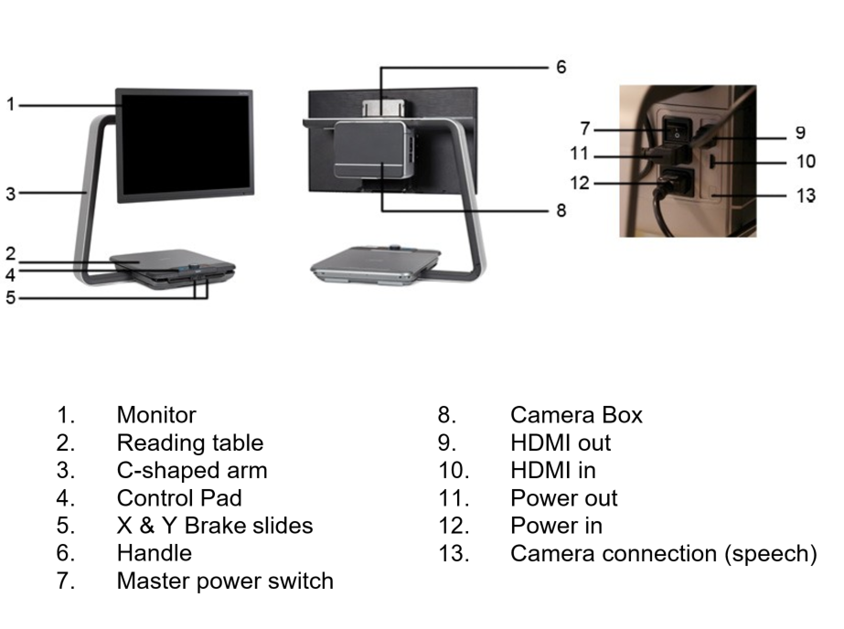

Unpacking and installing
The ClearView C is shipped in one box and is already assembled. All you have to do is unpack the ClearView C, plug the power cord into the unit and plug the power cord into the power socket.

To power on the ClearView C, please take the following steps:
- Plug the power cord into the power socket;
- Press the On / Off button at the left side of the Electronic Box.

2.1 Switching the table setup
The ClearView C has two table setups: the Compact setup and the wide Comfort setup. The Compact setup is the standard setup. If you would like to have more space, for instance when doing craftwork or reading larger documents, you can switch to the Comfort setup. Please refer to the ‘Instruction Sheet for switching the table setup’ for step-by-step pictures.

To switch from the Compact to Comfort setup:
- Remove the cap from the top of the C-shaped arm;
- Loosen the black knob;
- Slide the monitor and the camera box to the right by slightly lifting them;
- Secure the black knob and place the cap back on the arm;
- Release the brakes and slide the table top to the right;
- Loosen the black knob;
- Slide the table top back to its position and secure the brakes by sliding them to the middle;
- Hold the table and pull the arm out until you hear a click;
- Slide the table top to the right and secure the black knob;

To switch back to the Compact setup:
- Remove the cap from the top of the C-shaped arm;
- Loosen the black knob;
- Slide the monitor and the camera box to the left by slightly lifting them;
- Secure the black knob and place the cap back on the arm.
- Release the brakes and slide the table top to the right;
- Loosen the black knob;
- Slide the table top back to its position and secure the brakes;
- Hold the table and push the arm into the table until you hear a click;
- Slide the table top to the right and secure the black knob;

Operation

3.1 Introduction
When using the ClearView C, place your hands on the wrist support at the front of the table for easy access to the Control Pad buttons and for steady table movement.

The ClearView C is equipped with a wireless Control Pad, located between the two wrist supports in the reading table. If the Control Pad is placed in the reading table with the Optelec logo facing you, the ClearView C buttons for the basic functionality are accessible.

To access the buttons for the Advanced functionality, simply rotate the Control Pad so five rectangular buttons are facing you.

3.2 The Basic Control Pad
The Basic Control Pad is correctly placed in the reading table when the Optelec logo is facing you, and three large buttons are on top of the Control Pad.
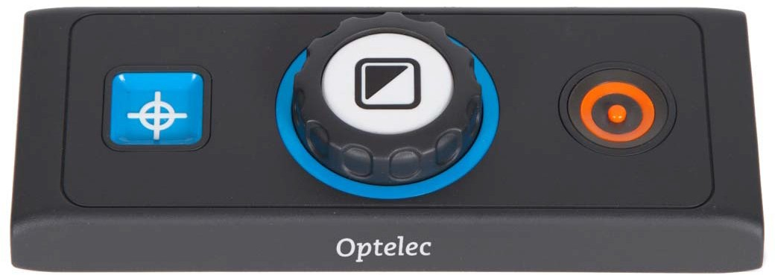

3.2.1 Power On / Off
To power on both the system and monitor, press the orange round On / Off button located next to the Zoom dial on the Control Pad. The ClearView C will start up in the same viewing mode as when it was powered off.

It takes about 5 seconds for the camera unit to initialize before it displays an image.
In case the ClearView does not power on, make sure all cables are connected and that the power switch, located at the left side of the camera box behind the monitor, is in its ON position.

3.2.2. Adjusting the magnification
Locate the Zoom dial in the center of the Control Pad. Turn it clockwise to increase the magnification, and counter- clockwise to decrease the magnification.

3.2.3 Choosing viewing modes
Pressing the white Mode button inside the Zoom dial will cycle you through a maximum of five different viewing modes, depending on how the system is configured:
- Full colour photo mode: This mode displays the original colours of the pictures and text.
- Reading mode 1: This mode enhances the foreground / background contrast. Pictures and text will be displayed in the configured high contrast foreground and background colour, by default black text on a white background. The foreground and background colours can be changed in the ClearView C Menu;
- Reading mode 2 (optional): This mode enhances the foreground / background contrast. Pictures and text will be displayed in the configured high contrast foreground and background colour, by default white text on a black background. The foreground and background colour can be changed or disabled in the ClearView C Menu;
- Reading mode 3 (optional): This mode enhances the foreground / background contrast. Pictures and text will be displayed in the configured high contrast foreground and background colour. By default this mode is disabled. The foreground and background colour can be enabled and changed in the ClearView C Menu;
- Reading mode 4 (optional): This mode enhances the foreground / background contrast. Pictures and text will be displayed in the configured high contrast foreground and background colour. By default this mode is disabled. The foreground and background colour can be enabled and changed in the ClearView C Menu.

3.2.4 Object lighting On /Off
Pressing the white Mode button for four seconds turns off the object lighting. You may want to temporarily turn off the object lighting to eliminate light reflections. If you press this button again, you will continue to the next reading mode and the lights will turn back on. Pressing the button for four seconds will turn the object lighting back on but will not advance to the next reading mode.

3.2.5 Overview function (position locator)
The overview function provides you with a quick overview of the text, which helps you to easily locate the part of a document which is of interest.
Press the blue square Overview button to activate the overview function. When the overview function is activated, the ClearView C will automatically zoom out to the minimum magnification, and will display a crosshair target to indicate the center of the screen. Position the text you wish to read in the crosshair’s target by moving the reading table. Once the document has been positioned, press the button once again to zoom in on the selected text in your previous magnification setting.

3.2.6 Pointer (position locator)
Pressing the blue square Overview button for three seconds will activate a red LED light, which shows as a red spotlight on the reading table. The pointer helps you locate where the camera looks on the table. For instance: when writing, place your pen in the red spotlight on the reading table and the pen will be displayed in the center of your screen. Press this button once again to deactivate the LED light. After 30 seconds, the pointer will automatically be deactivated.

3.2.7 Reading table brake and friction control
Use the two sliders at the front of the reading table to apply friction to the left / right direction or up / down direction movement or to lock the left / right or up / down direction. When the sliders are positioned towards the outer left and right edge of the table, the table can move freely up, down, left and right. To apply more friction, move the sliders towards the center of the table, whereby the left slider adjusts the friction in the left / right direction, while the right slider adjusts the friction in the up / down direction. To apply maximum friction to the left / right movement, slide the left slider to the center of the table. Alternatively, to apply the maximum friction to the up / down movement, slide the right slider to the center position. Adjusting the friction or locking the table can be useful when writing, painting, doing hobbies and crafts, moving the ClearView C, or when you are not using the ClearView C.

3.3 The Advanced Control Pad
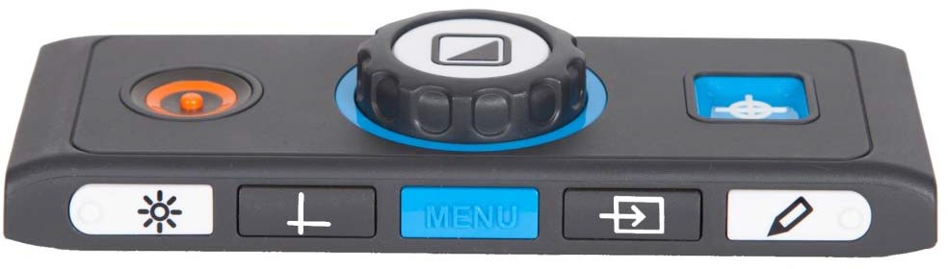The Advanced Control Pad is correctly placed in the reading table when five rectangular buttons are facing you and three larger buttons are on top of the Control Pad.

3.3.1 Adjusting the image control
If characters or other on-screen elements are not clearly visible, use the image control to enhance the image and increase the sharpness. To adjust the image control, press the white Image Control button marked with a dot and a “sun” icon once (most left button). Now use the Zoom dial to adjust the image control. If no button is pressed within three seconds, the Zoom dial will revert back to its original zoom function.

3.3.2 Activating line markers / window shades
Pressing the grey Lines / Windows button (second button from the left) cycles you through the line markers, window shades and full screen camera image modes. Line markers are used as guides to make reading text easier or to help you write under the ClearView C. The window shades function is used to block a part of an image when screen brightness becomes inconvenient or when you need to concentrate on only one or two lines of text.

3.3.3 Positioning line markers / window shades
When line markers or window shades are activated, the top or left line or window shade blinks to indicate it can be moved up, down, left and / or right. Use the Zoom dial to move the line marker or window shade. Press the Mode button to adjust the other line or window shade. To move the other line marker or window shade use the Zoom dial again. If no button is pressed for 3 seconds, the Zoom dial reverts back to its original zoom function and the blinking of the line marker or window shade stops. Press the dial again to disable the line markers / window shades.

3.3.4 Activating the ClearView C Menu
Press the blue Menu button in the middle, marked with the word “Menu” to activate the ClearView C settings menu. For more information about the ClearView C menu, please refer to chapter 4.

3.3.5 Switching between the ClearView C and a computer / external source image
If a computer or another external source is connected to the ClearView C, press the grey PC button marked with an arrow (second button from the right) to toggle between the ClearView C image and the full screen computer image.
To display the computer image on your ClearView C monitor correctly, make sure that your computer’s resolution is set to 1920 x 1080.

3.3.6 Auto-focus lock
The ClearView C features an automatic focus camera that produces a sharp on-screen image at any time. When switching the ClearView C on, the system will start up in the auto-focus mode. Pressing the Auto-focus button marked with a dot and a pencil icon (most right button) stops the ClearView C from continuously operating the auto-focus feature and fixes the focus on the object being viewed. This can be useful for writing, painting or crafts. When the auto-focus feature is disabled, an icon with a pencil will be displayed in the top right corner. To enable the auto-focus, simply press the Auto-focus button and the icon will disappear from the top right corner to indicate the auto-focus is switched on again.

3.3.7 The Control Pad Batteries

The ClearView C Control Pad is powered by two coin cell batteries of the type CR2025. These batteries last for two to three years. If the Control Pad buttons stop functioning, and the ClearView C is more than two years old, or it is more than two years ago that the batteries of the Control Pad have been changed, please change the batteries. To change the batteries, gently open the battery tray on the side of the Control Pad and replace the two batteries.

3.3.8 Pairing the Control Pad
In case the Control Pad is missing or defective, and needs to be replaced with a new Control Pad, the new Control Pad needs to be paired with the ClearView C. To pair the Control Pad follow these steps:

- Switch the ClearView C on;
- Hold the Control Pad vertically and hold the bottom of the Control Pad against the right side of the camera box behind the monitor;
- An icon will appear indicating the start of the pairing procedure;
- Press the On / Off button and the Overview button simultaneously for five seconds and release the buttons;
- If the pairing procedure is successful, the pairing icon will disappear;
- If the ClearView C does not recognize or see the Control Pad, the pairing sequence will be terminated within 30 seconds and the pairing icon will disappear. Repeat steps 1 to 5 until the Control pad is correctly paired. Possible causes for an unsuccessful pairing are:
  - The batteries of the Control Pad are empty;
  - The wrong buttons were pressed to initiate the pairing process;
  - The Control Pad is broken.

The ClearView C Menu

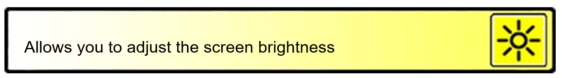

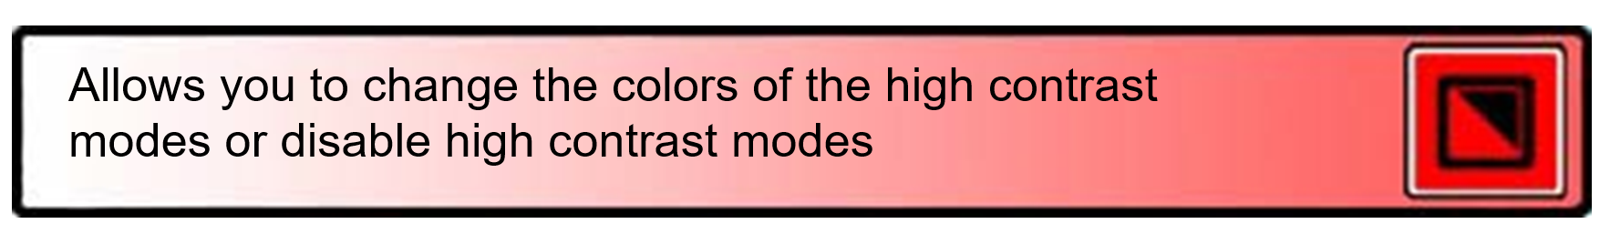

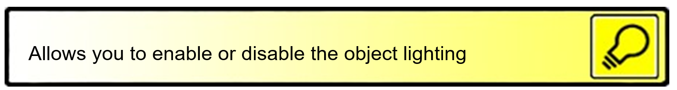

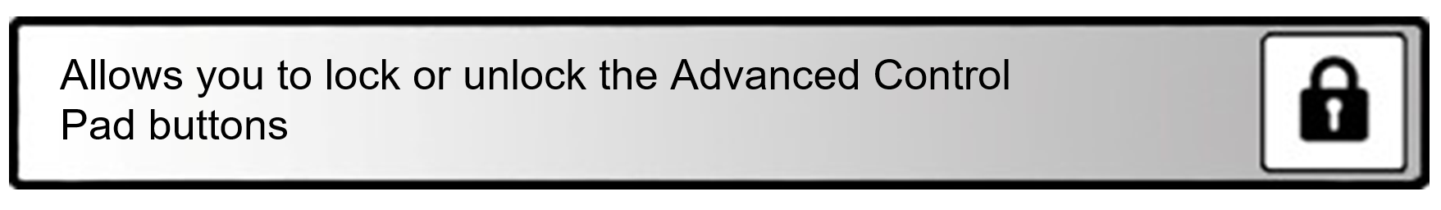

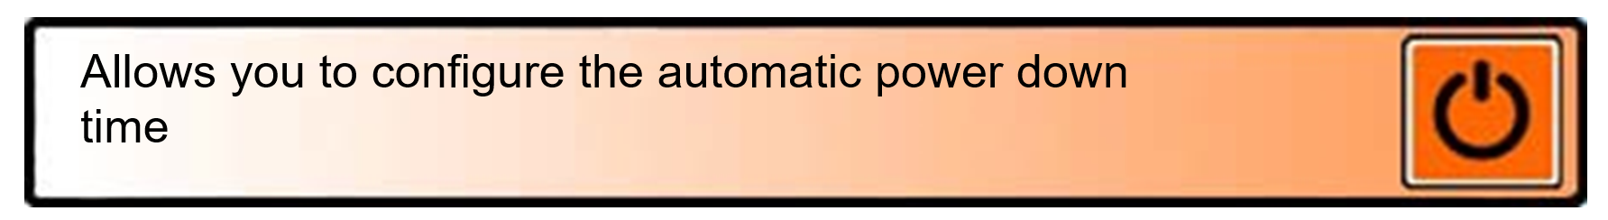
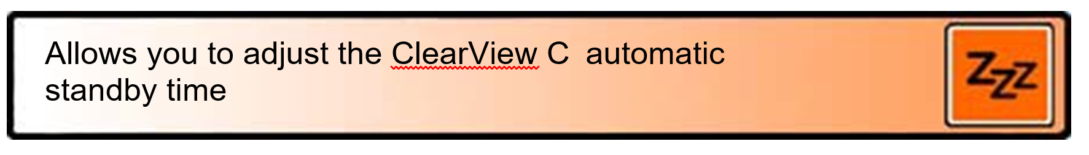
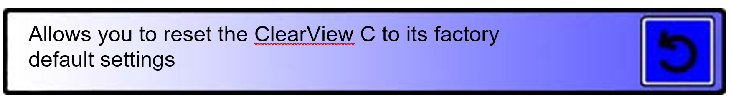
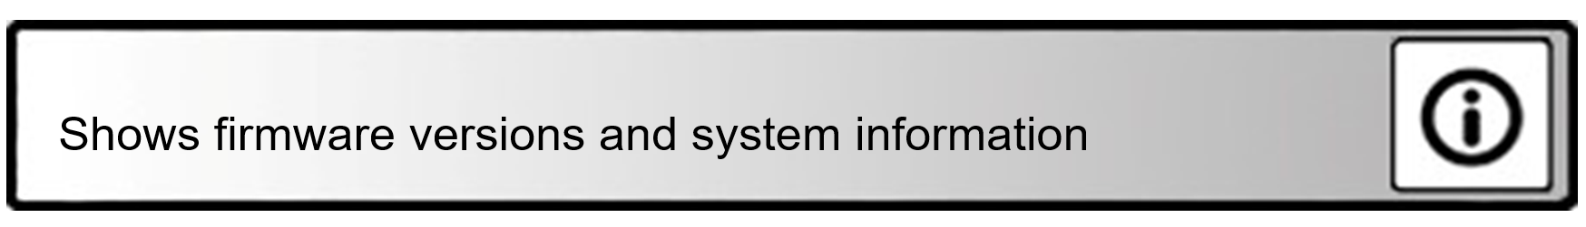

Activating the menu
To enter the menu, press the Menu button located at the front in the middle of the Advanced side of the Control Pad. To exit the menu, press the Menu button again.

Navigating the menu
Use the Zoom dial to scroll through the menu items. The Mode button located in the middle of the Zoom dial will activate the chosen menu item or confirm the selection.

Exiting the menu
To exit the menu, to go back to the previous menu level or to cancel your choice, press the Menu button on the Advanced side of the Control Pad. This menu item allows you to adjust the brightness.

Brightness
This menu item allows you to adjust the brightness of the screen.
- Activate the menu by pressing the Menu button on the Advanced side of the Control Pad.
- Use the Zoom dial to scroll through the menu items. Select the menu option Brightness and activate this menu by pressing the Mode button.
- Select the brightness level by using the Zoom dial to decrease or increase the brightness level. There are five brightness levels to choose from. The default brightness level is set to 5.
- Press the Mode button to confirm your choice and exit the menu.
The ClearView C supports four high contrast modes and the default photo mode. For each of the four high contrast modes, the foreground and background colors can be configured. Three of the high contrast modes can be disabled if you prefer to work with one high contrast mode. By default three are enabled: Full color photo mode, high contrast mode 1 white background with black text and high contrast mode 2 black background with white text. In addition to the color combinations, there is a greyscale option.

- Activate the menu by pressing the Menu button on the Advanced side of the Control Pad.
- Use the Zoom dial to scroll through the menu items. Select the menu option Color and activate this menu by pressing the Mode button.
- Select one of the four high contrast modes with the Zoom dial and press the Mode button to confirm your choice.
- To select a new high contrast colour combination, use the Zoom dial to scroll through the list of colour combinations. Select a colour combination by pressing the Mode button.
- High contrast modes 2, 3 and 4 can be disabled by selecting ‘off’.
- Press the Mode button to confirm your choice and exit the menu.

You can select the following color combinations:

  - Black – White
  - White – Black
  - Yellow – Black
  - Black – Yellow
  - Yellow – Blue
  - Blue – Yellow
  - Black – Red
  - Red – Black
  - Black – Green
  - Green – Black
  - Black – Purple
  - Purple – Black
  - Blue – White
  - White – Blue
  - Black – Amber
  - Amber – Black
  - Greyscale

This menu item allows you to enable or disable the object light – located at the left and right of the camera – when the unit is switched on. By default, the object light is enabled. If you select ‘off’, the light will be off when the unit is switched on.

- Activate the menu by pressing the Menu button on the Advanced side of the Control Pad.
- Use the Zoom dial to scroll through the menu. Select the menu option Light and activate this menu option by pressing the Mode button.
- To enable the object light, select the value ‘on’ with the Zoom dial. Selecting ‘off’ will disable the object light. Press the Mode button to confirm your choice and exit the menu.

This menu item allows you to lock or unlock the Advanced buttons on the Control Pad, with the exception of the Menu button. If the lock is enabled, the Advanced buttons Brightness, Lines, PC and Auto-focus are locked. The Menu button remains unlocked.

- Activate the menu by pressing the Menu button on the Advanced side of the Control Pad.
- Use the Zoom dial to scroll through the menu. Select the menu option Lock and activate this menu option by pressing the Mode button.
- To lock the Advanced Control Pad, select ‘on’ with the Zoom dial. Press the Mode button to confirm your choice. Selecting ‘off’ will unlock the Advanced Control Pad.
- Press the Mode button to confirm your choice and exit the menu
This menu item sets the time before the ClearView C is automatically powered off. By default, the power off time is set to 5 minutes. These 5 minutes are activated after the default standby time of 15 minutes. By default, the unit is therefore automatically switched off after 20 minutes. The Power off time can be set to 5, 15, 30 minutes and to ‘never’.

- Activate the menu by pressing the Menu button on the Advanced side of the Control Pad.
- Use the Zoom dial to scroll through the menu items. Select the menu option Power off and activate this menu by pressing the Mode button.
- Select the time interval with the Zoom dial. Press the Mode button to confirm your choice. Selecting ‘never’ will disable the automatic power off function.
- Press the Mode button to confirm your choice and exit the menu.

This menu item sets the time before the ClearView C goes into standby mode
to conserve power. Pressing any button will take the unit out of standby mode. By default, the standby time is set to 15 minutes. The standby time can be set to 5, 15, 30 minutes and ‘never’.

By pressing the On / Off button, the unit will always go into standby mode first, after which it will power down using the power off time setting.

- Activate the menu by pressing the Menu on the Advanced side of the Control Pad.
- Use the Zoom dial to scroll through the menu items. Select the menu option Standby and activate this menu by pressing the Mode button.
- Select the time after which the unit will go into standby mode with the Zoom dial. Press the Mode button to confirm your choice. Selecting ‘never’ will disable the automatic standby function.
- Press the Mode button to confirm your choice and exit the menu.

This menu item lets you reset the ClearView C to the factory default settings.

- Activate the menu by pressing the Menu button on the Advanced side of the Control Pad.
- Use the Zoom dial to scroll through the menu. Select the menu option Reset and activate this menu option by pressing the Mode button.
- To restore the factory defaults, select ‘yes’ by using the Zoom dial.
Choosing ‘no’ will leave all settings as they are.
- Press the Mode button to confirm your choice and exit the menu.

Alternatively:

- Press and hold the Power button for five seconds.
This menu item displays the firmware versions and system information. No changes can be made in this menu.

- Activate the menu by pressing the Menu button on the Advanced side of the Control Pad.
- Use the Zoom dial to scroll through the menu. Select the menu option Information and activate this menu option by pressing the Mode button.
- To exit the menu, press the Menu button.
This menu item lets you exit the menu.

- Activate the menu by pressing the Menu button on the Advanced Control Pad.
- Use the Zoom dial to scroll through the menu. Select the menu option Exit and activate this menu option by pressing the Mode button to exit the menu.
Or
- Press the Menu button.

5. Adjusting the monitor
The ClearView C monitor can be adjusted in height and viewing angle for a comfortable reading position. The monitor can be moved up and down and can be tilted vertically for optimal viewing comfort.

To place the monitor in your preferred position, firmly grip the flat panel on both sides by the surrounding frame and move the monitor up or down, or adjust the viewing angle by tilting the monitor vertically.

The ClearView C is equipped with feet of special soft material to make rotating or moving the unit on the table surface easier. Firmly grip the stand of the ClearView C and rotate or move the unit to reposition the ClearView C on the table for an optimal viewing distance and viewing angle.

Warning
Before moving or rotating the ClearView C, make sure there is enough free space on the table to move the unit, that there are no other objects placed on the table, and that the power cable is long enough to move the unit. Make sure that the table is a flat horizontal surface. Do not move the ClearView C off the table as that may cause serious injuries.

6. The carrying handle
The ClearView C is equipped with a carrying handle, located behind the monitor. To prevent injuries, please make sure to lock the carrying handle in place and to lock the table using the two brake sliders before lifting the ClearView C on the handle. To lock the handle:
  - Move the monitor down to its lowest position;
  - Lift the handle behind the monitor. If the monitor is moved to its lowest position, the handle will lock in place.
  - Lock the table by placing the table in its home position and moving the brake sliders to the lock position and confirm that the table is locked.
  - Now you can safely lift the ClearView C.

To unlock the handle:
Firmly grip the monitor and move the monitor up.

Troubleshooting

Manufacturer’s default settings
If you experience any difficulty operating the system, you can reset the factory default settings. Switch the ClearView C off with the Master Power Switch and wait 3 seconds. Switch the unit back on. Then, press and hold the On / Off button for 5 seconds. Alternatively, reset the ClearView C selecting the reset option from the ClearView C Menu.

No image on the ClearView C monitor after it is switched on
- Check if all cables and hardware are connected properly and securely.
- Check that the master power switch at the left side of the camera box, behind the monitor, is switched on.

None of the buttons of the Control Pad work
- Ensure that the batteries of the Control Pad are not empty. The Control Pad batteries last for two to three years.
- Make sure the Control Pad is paired with the ClearView C. If not, pair the Control Pad.

Image is not in focus
- If the pencil icon is displayed in the top right corner of the screen, press the Auto-focus button to return to auto-focus mode.
- Clean the monitor screen with a non-abrasive cloth.

Pictures and text look grey or have low contrast
- Press the mode button to switch to the high contrast reading mode.
- Adjust the Image Control on the Control Pad.
- Adjust the brightness level in the menu.

The computer image is not displaying
- Verify the computer’s video (HDMI) connection to the ClearView C camera box (do not connect the PC directly to the monitor).
- Make sure the PC resolution is set to 1920x1080.
- Check the computer for any malfunction by connecting the PC directly into the monitor.

The reading table does not move or does not move smoothly
  - Make sure the brake slides are positioned towards the outer edges of the table.
  - Inspect the slides for dust or any other obstructions

Safety and Regulatory Notices
Please read the instructions carefully before setting up your ClearView C. Keep this user manual for future reference.

- Use the ClearView C indoors. Do not expose the ClearView C to extreme or rapid changes in temperature or humidity. Do not place the ClearView C near a radiator or heater, or where it may be exposed to direct sunlight. These conditions may damage the ClearView C’s electronic or optical components.
- Do not place the ClearView C on an unstable surface. It may fall, causing serious damage to the unit, or injury to the user.
- Firmly grip the monitor by the surrounding frame when positioning to ensure stability to the entire system.
- The reading table, handle and the monitor adjustment contain movable parts. Please be careful when adjusting the screen position, handle, or when operating the reading table as to prevent fingers or any loose clothing from getting caught in the operating mechanism. If you have difficulty operating the ClearView C safely, please seek assistance or contact your Optelec distributor.
- When carrying the ClearView C using the handle, please make sure the monitor is moved down to its lowest position, the reading table is locked and the handle is locked before lifting the unit as to prevent fingers or any loose clothing from getting caught in the operating mechanism. If you have difficulty operating the ClearView C handle safely, please seek assistance or contact your Optelec distributor.
- Contact your Optelec distributor to service the ClearView C if necessary. Do not open your ClearView C; this will void the warranty.
- When moving the ClearView C to another location, carry the ClearView C by gripping the stand or using the integrated handle.
- Always switch the power off when the ClearView C is not in use.
- Always unplug the ClearView C before cleaning it. Use a soft cloth to clean the exterior surfaces. Do not use any cleaning agents or any abrasive materials as these will damage your ClearView C.
- Only use the cables provided with the unit.

